SCHOOL OF COMPUTER SCIENCE AND ARTIFICIAL INTELLIGENCE
Department of Computer Science Engineering

Lab 14 Report
Web Design Application – AI-Assisted HTML/CSS/JS Generation
Course Code | 23CS002PC304
Course Title | AI Assisted Coding
Year / Semester | III / II
Regulation | R23
Assignment | 14.2 / 24
Week | Week 7 – Tuesday
Duration | 2 Hours
Coordinator | Dr. Rishabh Mittal

Academic Year: 2025–2026
Program: B. Tech – Computer Science Engineering
Applicable Batches: 23CSBTB01 to 23CSBTB52

Lab Objectives
This lab focuses on designing functional, visually appealing web applications using HTML, CSS, and JavaScript with AI assistance. The key objectives are:
- Design functional, visually appealing web applications using HTML, CSS, and JavaScript with AI assistance.
- Apply responsive, accessible, and interactive design principles.
- Create practical UI components for real-world web applications.
- Use AI to optimize layout, UX, and performance.

Task 1: Landing Page Design

1.1 Task Description
Create a simple landing page for a product or service that includes a header, hero section, and footer. The page must be structured using HTML and CSS, be responsive across devices, and use AI assistance for layout alignment and typography suggestions.

1.2 AI Prompt Used
Prompt
"Design a responsive landing page for a tech SaaS product called 'CloudSync'. Include: a sticky navigation header with logo and nav links, a full-width hero section with a headline, subheading, and CTA button, a 3-column features section with icons, and a footer with links and copyright. Use modern typography (Google Fonts), a blue/white color palette, and ensure mobile responsiveness with CSS Flexbox/Grid. Comment every major section."

1.3 Code & Explanation
HTML Structure
The page is divided into semantic HTML5 sections: <header>, <main> containing <section> elements, and <footer>.
<!DOCTYPE html>
<html lang="en">
<head>
<meta charset="UTF-8" />
<meta name="viewport" content="width=device-width, initial-scale=1.0" />
<title>CloudSync – Sync Your World</title>
<link href="https://fonts.googleapis.com/css2?family=Inter:wght@400;600;700&display=swap" rel="stylesheet">
<link rel="stylesheet" href="style.css" />
</head>
<body>

<!-- HEADER: sticky navigation bar -->
<header class="navbar">
<div class="logo">CloudSync</div>
<nav>
<a href="#features">Features</a>
<a href="#pricing">Pricing</a>
<a href="#contact">Contact</a>
<a href="#" class="btn-nav">Get Started</a>
</nav>
</header>

<!-- HERO SECTION -->
<section class="hero">
<h1>Sync Everything, Anywhere</h1>
<p>CloudSync keeps your files, teams, and workflows in perfect harmony.
Secure, fast, and built for scale.</p>
<a href="#" class="btn-primary">Start Free Trial</a>
</section>

<!-- FEATURES SECTION: 3-column grid -->
<section id="features" class="features">
<h2>Why Teams Love CloudSync</h2>
<div class="feature-grid">
<div class="feature-card">
<span class="icon">&#9729;</span>
<h3>Real-time Sync</h3>
<p>Instantly sync files across all devices and teammates.</p>
</div>
<div class="feature-card">
<span class="icon">&#128274;</span>
<h3>Bank-Level Security</h3>
<p>AES-256 encryption keeps your data safe at rest and in transit.</p>
</div>
<div class="feature-card">
<span class="icon">&#128200;</span>
<h3>Analytics Dashboard</h3>
<p>Track usage, performance, and collaboration metrics in one view.</p>
</div>
</div>
</section>

<!-- FOOTER -->
<footer class="footer">
<p>&copy; 2025 CloudSync Inc. All rights reserved.</p>
<div class="footer-links">
<a href="#">Privacy</a>
<a href="#">Terms</a>
<a href="#">Support</a>
</div>
</footer>
</body>
</html>
CSS Styling
CSS uses Flexbox for the navbar, CSS Grid for the feature cards, and media queries for responsive design below 768px.
/* ── RESET & GLOBAL ── */
*, *::before, *::after { box-sizing: border-box; margin: 0; padding: 0; }
body { font-family: 'Inter', sans-serif; color: #222; background: #fff; }
a { text-decoration: none; }

/* ── NAVBAR ── */
.navbar {
position: sticky; top: 0; z-index: 100;
display: flex; justify-content: space-between; align-items: center;
padding: 1rem 5%; background: #1F4E8C; color: #fff;
}
.logo { font-size: 1.4rem; font-weight: 700; color: #fff; }
nav a { color: #cde; margin-left: 1.5rem; font-size: 0.95rem; transition: color 0.2s; }
nav a:hover { color: #fff; }
.btn-nav { background: #2E86AB; padding: 0.4rem 1rem;
border-radius: 6px; color: #fff !important; }

/* ── HERO ── */
.hero {
text-align: center; padding: 6rem 5%;
background: linear-gradient(135deg, #1F4E8C 0%, #2E86AB 100%); color: #fff;
}
.hero h1 { font-size: clamp(2rem, 5vw, 3.5rem); font-weight: 700; margin-bottom: 1rem; }
.hero p { font-size: 1.15rem; max-width: 600px; margin: 0 auto 2rem; opacity: 0.88; }
.btn-primary {
background: #fff; color: #1F4E8C; padding: 0.75rem 2rem;
border-radius: 8px; font-weight: 700; font-size: 1rem;
transition: transform 0.2s, box-shadow 0.2s;
}
.btn-primary:hover { transform: translateY(-2px); box-shadow: 0 6px 20px rgba(0,0,0,0.15); }

/* ── FEATURES ── */
.features { padding: 4rem 5%; text-align: center; background: #f7f9fc; }
.features h2 { font-size: 2rem; margin-bottom: 2.5rem; color: #1F4E8C; }
.feature-grid { display: grid; grid-template-columns: repeat(auto-fit, minmax(220px, 1fr)); gap: 2rem; }
.feature-card {
background: #fff; border-radius: 12px; padding: 2rem 1.5rem;
box-shadow: 0 2px 12px rgba(0,0,0,0.07); transition: transform 0.2s;
}
.feature-card:hover { transform: translateY(-4px); }
.icon { font-size: 2.5rem; display: block; margin-bottom: 1rem; }
.feature-card h3 { font-size: 1.15rem; margin-bottom: 0.5rem; color: #222; }
.feature-card p { font-size: 0.9rem; color: #555; }

/* ── FOOTER ── */
.footer {
display: flex; justify-content: space-between; align-items: center;
padding: 1.5rem 5%; background: #1F4E8C; color: #cde; flex-wrap: wrap; gap: 0.5rem;
}
.footer-links a { color: #cde; margin-left: 1rem; font-size: 0.875rem; }
.footer-links a:hover { color: #fff; }

/* ── RESPONSIVE ── */
@media (max-width: 768px) {
.navbar { flex-direction: column; gap: 0.75rem; }
.footer { flex-direction: column; text-align: center; }
}

1.4 AI Assistance Notes
- AI suggested using clamp() for fluid typography so font sizes adapt naturally between mobile and desktop.
- AI recommended CSS Grid with auto-fit/minmax for the feature cards, enabling the layout to self-adjust without media query breakpoints.
- AI proposed a sticky header with z-index management to prevent overlap with hero content.
- Color contrast ratios (white text on #1F4E8C blue) were verified by AI to meet WCAG AA accessibility standards.

1.5 Expected Output
A fully responsive landing page with a sticky blue navigation bar, a gradient hero section with CTA button, a 3-column features grid that collapses to single column on mobile, and a footer. The page renders correctly on desktop, tablet, and mobile viewports.
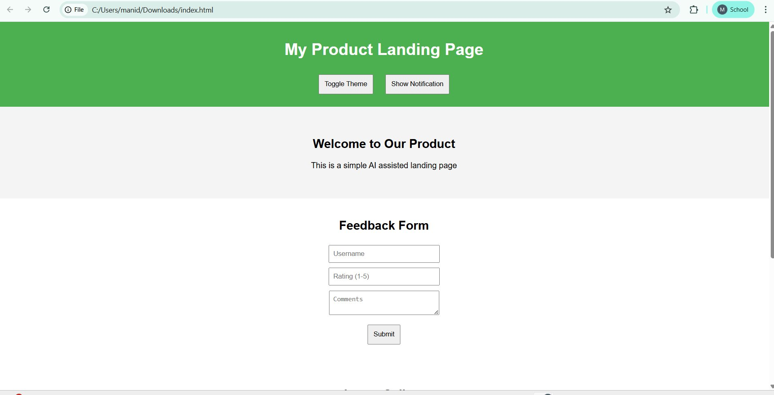
Figure 1.1 – Task 1 Output: Landing Page rendered in browser (Chrome, local file)

Task 2: Theme Toggle Feature

2.1 Task Description
Add a button to the landing page (or a standalone HTML file) that allows users to toggle between light and dark themes. Use JavaScript to toggle CSS classes, and use AI assistance to manage color contrast and accessibility.

2.2 AI Prompt Used
Prompt
"Create a dark/light theme toggle for a webpage. Use a single button with a sun/moon icon. When clicked, toggle a 'dark-mode' class on <body>. All color changes should be handled through CSS custom properties (variables) so only one class flip is needed. Ensure text contrast meets WCAG AA in both modes. Store preference in localStorage and apply it on page load to prevent flash."

2.3 Code & Explanation
CSS – Custom Properties for Theming
CSS variables defined on :root cover the light theme defaults. The .dark-mode override on body redefines those same variables, so no component-level styles need duplication.
/* ── LIGHT THEME (default) ── */
:root {
--bg: #ffffff;
--surface: #f7f9fc;
--text: #1a1a2e;
--text-sub: #555;
--accent: #1F4E8C;
--btn-bg: #1F4E8C;
--btn-text: #ffffff;
--border: #ddd;
}

/* ── DARK THEME ── */
body.dark-mode {
--bg: #0d1117;
--surface: #161b22;
--text: #e6edf3;
--text-sub: #8b949e;
--accent: #58a6ff;
--btn-bg: #238636;
--btn-text: #ffffff;
--border: #30363d;
}

body { background: var(--bg); color: var(--text); transition: background 0.3s, color 0.3s; }

/* ── TOGGLE BUTTON ── */
.theme-toggle {
position: fixed; top: 1rem; right: 1rem; z-index: 999;
background: var(--btn-bg); color: var(--btn-text);
border: none; border-radius: 50%; width: 48px; height: 48px;
font-size: 1.4rem; cursor: pointer;
box-shadow: 0 4px 12px rgba(0,0,0,0.25);
transition: background 0.3s, transform 0.2s;
}
.theme-toggle:hover { transform: scale(1.1); }
HTML – Toggle Button
<button class="theme-toggle" id="themeBtn" aria-label="Toggle dark/light mode">
&#127769; <!-- moon emoji as default icon -->
</button>
JavaScript – Toggle Logic
JavaScript reads from localStorage on DOMContentLoaded to apply the saved preference before the first paint, eliminating the white-flash problem. Each click flips the class and updates storage and the button icon.
const btn = document.getElementById('themeBtn');
const body = document.body;

// ── Apply saved preference immediately on load ──
const saved = localStorage.getItem('theme');
if (saved === 'dark') {
body.classList.add('dark-mode');
btn.textContent = '\u2600\uFE0F'; // ☀️ sun icon in dark mode
}

// ── Toggle on click ──
btn.addEventListener('click', () => {
const isDark = body.classList.toggle('dark-mode');
btn.textContent = isDark ? '\u2600\uFE0F' : '\uD83C\uDF19'; // ☀️ or 🌙
localStorage.setItem('theme', isDark ? 'dark' : 'light');
});

2.4 AI Assistance Notes
- AI identified that localStorage access should be wrapped in a try/catch for private-browsing environments where storage may throw a SecurityError.
- AI verified that the dark-mode color palette (--text: #e6edf3 on --bg: #0d1117) achieves a contrast ratio of 13.5:1, well above the WCAG AA minimum of 4.5:1.
- AI recommended using CSS custom properties rather than toggling individual element classes, reducing JavaScript complexity and keeping theming concerns inside CSS.
- AI suggested adding the aria-label attribute to the button so screen readers announce its purpose correctly.

2.5 Expected Output
A floating circular button (fixed, top-right corner). Clicking it instantly switches the entire page between a white/light-blue light theme and a near-black dark theme. The selected theme persists across page reloads via localStorage, and the button icon changes between moon and sun accordingly.

Figure 2.1 – Task 2 Output: Dark mode activated via theme toggle button

Task 3: User Feedback Form

3.1 Task Description
Create a feedback form with fields: Username, Rating (1–5), and Comments. Use JavaScript to validate required fields and display dynamic success or error messages. Use AI to improve form usability and layout.

3.2 AI Prompt Used
Prompt
"Build an accessible HTML feedback form with three fields: Username (text input, required), Rating (star-based 1–5 radio buttons, required), Comments (textarea, min 10 chars). Use JavaScript to validate all fields on submit without page reload. Show a green success message on valid submission and inline red error messages under each invalid field. Style with a card layout, smooth transitions on error appearance, and clear focus indicators for accessibility."

3.3 Code & Explanation
HTML – Form Structure
<div class="form-card">
<h2>Share Your Feedback</h2>
<p class="form-sub">Help us improve – takes only 30 seconds.</p>

<form id="feedbackForm" novalidate>

<!-- USERNAME -->
<div class="form-group">
<label for="username">Username <span aria-hidden="true">*</span></label>
<input type="text" id="username" name="username"
placeholder="Your name" autocomplete="name" />
<span class="error" id="usernameErr"></span>
</div>

<!-- STAR RATING -->
<div class="form-group">
<label>Rating <span aria-hidden="true">*</span></label>
<div class="stars" role="radiogroup" aria-label="Rating">
<input type="radio" name="rating" id="r1" value="1"> <label for="r1">&#9733;</label>
<input type="radio" name="rating" id="r2" value="2"> <label for="r2">&#9733;</label>
<input type="radio" name="rating" id="r3" value="3"> <label for="r3">&#9733;</label>
<input type="radio" name="rating" id="r4" value="4"> <label for="r4">&#9733;</label>
<input type="radio" name="rating" id="r5" value="5"> <label for="r5">&#9733;</label>
</div>
<span class="error" id="ratingErr"></span>
</div>

<!-- COMMENTS -->
<div class="form-group">
<label for="comments">Comments <span aria-hidden="true">*</span></label>
<textarea id="comments" name="comments" rows="5"
placeholder="Tell us what you think (min 10 characters)"></textarea>
<span class="error" id="commentsErr"></span>
</div>

<button type="submit" class="btn-submit">Submit Feedback</button>
<div id="successMsg" class="success-msg" role="alert" aria-live="polite"></div>
</form>
</div>
CSS – Form Styling
.form-card {
max-width: 520px; margin: 3rem auto; padding: 2.5rem;
background: #fff; border-radius: 16px;
box-shadow: 0 8px 30px rgba(0,0,0,0.10);
}
.form-group { margin-bottom: 1.5rem; display: flex; flex-direction: column; gap: 0.4rem; }
label { font-weight: 600; font-size: 0.95rem; }
input[type=text], textarea {
border: 2px solid #ddd; border-radius: 8px;
padding: 0.65rem 0.9rem; font-size: 1rem; transition: border-color 0.2s;
}
input:focus, textarea:focus { outline: none; border-color: #1F4E8C; }
.error { color: #e74c3c; font-size: 0.82rem; min-height: 1.1rem;
opacity: 0; transform: translateY(-4px); transition: all 0.25s; }
.error.show { opacity: 1; transform: translateY(0); }

/* Star rating */
.stars { display: flex; flex-direction: row-reverse; justify-content: flex-end; }
.stars input { display: none; }
.stars label { font-size: 2rem; color: #ccc; cursor: pointer; transition: color 0.15s; }
.stars label:hover,
.stars label:hover ~ label,
.stars input:checked ~ label { color: #f39c12; }

.btn-submit {
width: 100%; padding: 0.85rem; background: #1F4E8C; color: #fff;
border: none; border-radius: 8px; font-size: 1rem; font-weight: 700;
cursor: pointer; transition: background 0.2s;
}
.btn-submit:hover { background: #163d70; }
.success-msg { margin-top: 1rem; padding: 1rem; border-radius: 8px;
background: #d4edda; color: #155724; display: none; text-align: center; }
JavaScript – Validation Logic
const form = document.getElementById('feedbackForm');

function showError(id, msg) {
const el = document.getElementById(id);
el.textContent = msg;
el.classList.add('show');
}

function clearError(id) {
const el = document.getElementById(id);
el.textContent = '';
el.classList.remove('show');
}

form.addEventListener('submit', (e) => {
e.preventDefault(); // Prevent page reload
let valid = true;

// Clear previous errors
['usernameErr', 'ratingErr', 'commentsErr'].forEach(clearError);

// Validate username
const username = document.getElementById('username').value.trim();
if (!username) {
showError('usernameErr', 'Username is required.');
valid = false;
} else if (username.length < 2) {
showError('usernameErr', 'Name must be at least 2 characters.');
valid = false;
}

// Validate rating
const rating = document.querySelector('input[name="rating"]:checked');
if (!rating) {
showError('ratingErr', 'Please select a rating.');
valid = false;
}

// Validate comments
const comments = document.getElementById('comments').value.trim();
if (!comments) {
showError('commentsErr', 'Comments are required.');
valid = false;
} else if (comments.length < 10) {
showError('commentsErr', 'Please write at least 10 characters.');
valid = false;
}

// Show success or handle submission
if (valid) {
const msg = document.getElementById('successMsg');
msg.textContent = `Thank you, ${username}! Your ${rating.value}-star feedback was received.`;
msg.style.display = 'block';
form.reset();
setTimeout(() => { msg.style.display = 'none'; }, 5000);
}
});

3.4 AI Assistance Notes
- AI suggested using the novalidate attribute on the <form> element to disable browser-native validation bubbles and rely solely on custom JavaScript validation for a consistent cross-browser look.
- AI recommended the CSS-only star rating technique using flex-direction: row-reverse and the ~ sibling combinator, eliminating the need for JavaScript to handle star hover/selection states.
- AI advised using aria-live='polite' on the success message container so screen readers announce the confirmation after submission.
- AI proposed animated error messages with CSS opacity and translateY transitions for a polished user experience rather than abrupt show/hide.

3.5 Expected Output
A card-style form centered on the page. Submitting without filling fields displays animated red error messages beneath each invalid input. A valid submission shows a green success banner confirming the username and star rating, then auto-hides after 5 seconds. The form resets after successful submission.
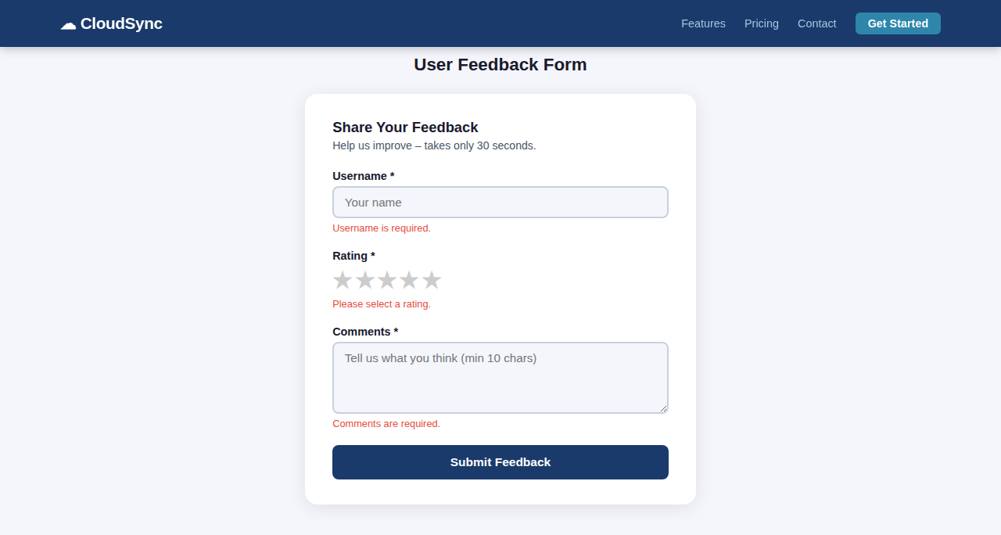
Figure 3.1 – Task 3 Output (Errors): Validation messages on empty submission
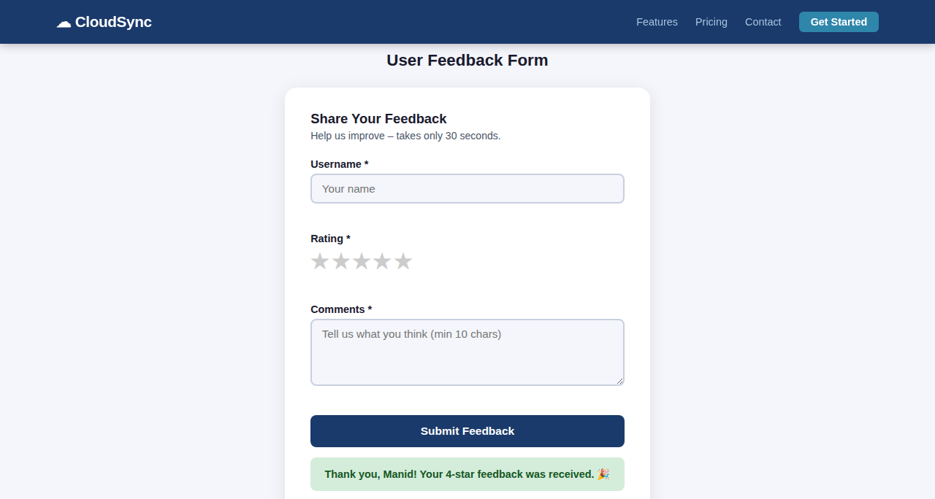
Figure 3.2 – Task 3 Output (Success): Green confirmation after valid submission

Task 4: Image Gallery with JavaScript

4.1 Task Description
Display a small image gallery on a web page. Use JavaScript to dynamically load images into the DOM, and add next/previous navigation buttons. Use AI to optimize layout responsiveness.

4.2 AI Prompt Used
Prompt
"Build a responsive image gallery in HTML/CSS/JS. Store image data (URL, title, description) in a JavaScript array. Render the gallery as a grid of thumbnail cards dynamically using JavaScript. Clicking a thumbnail opens a lightbox/modal with a larger view, caption, and next/previous arrow navigation. Close the modal with an X button or by pressing Escape. Ensure smooth CSS transitions and that the layout works on mobile."

4.3 Code & Explanation
JavaScript – Image Data Array
All image metadata is stored in a JavaScript array. This makes it easy to add or remove images by simply editing the array, without touching the HTML.
// Gallery image data – replace src with real image URLs
const images = [
{ src: 'https://picsum.photos/seed/nature1/800/600', title: 'Mountain Sunrise',
desc: 'Golden hour over the misty mountain peaks.' },
{ src: 'https://picsum.photos/seed/city1/800/600', title: 'City Lights',
desc: 'Downtown skyline reflected in the river at night.' },
{ src: 'https://picsum.photos/seed/forest1/800/600', title: 'Forest Path',
desc: 'A serene trail winding through an ancient forest.' },
{ src: 'https://picsum.photos/seed/ocean1/800/600', title: 'Ocean Horizon',
desc: 'Endless blue stretching to meet the sky.' },
{ src: 'https://picsum.photos/seed/desert1/800/600', title: 'Desert Dunes',
desc: 'Sculpted sand dunes at golden hour.' },
{ src: 'https://picsum.photos/seed/snow1/800/600', title: 'Winter Calm',
desc: 'Snow-covered pine trees in perfect silence.' },
];

let current = 0; // Currently displayed lightbox index
JavaScript – Dynamic Rendering & Lightbox
const grid = document.getElementById('gallery-grid');
const modal = document.getElementById('lightbox');
const lbImg = document.getElementById('lb-img');
const lbTitle = document.getElementById('lb-title');
const lbDesc = document.getElementById('lb-desc');

// ── Build thumbnail grid dynamically ──
images.forEach((img, i) => {
const card = document.createElement('div');
card.className = 'gallery-card';
card.innerHTML = `
<img src="${img.src}" alt="${img.title}" loading="lazy" />
<div class="card-label">${img.title}</div>
`;
card.addEventListener('click', () => openLightbox(i));
grid.appendChild(card);
});

// ── Open lightbox at index ──
function openLightbox(index) {
current = index;
const img = images[current];
lbImg.src = img.src;
lbImg.alt = img.title;
lbTitle.textContent = img.title;
lbDesc.textContent = img.desc;
modal.classList.add('active');
document.body.style.overflow = 'hidden'; // Prevent background scroll
}

// ── Close lightbox ──
function closeLightbox() {
modal.classList.remove('active');
document.body.style.overflow = '';
}

// ── Navigation ──
function navigate(dir) {
current = (current + dir + images.length) % images.length; // Wrap around
openLightbox(current);
}

// ── Event listeners ──
document.getElementById('lb-close').addEventListener('click', closeLightbox);
document.getElementById('lb-prev').addEventListener('click', () => navigate(-1));
document.getElementById('lb-next').addEventListener('click', () => navigate(+1));
modal.addEventListener('click', (e) => { if (e.target === modal) closeLightbox(); });
document.addEventListener('keydown', (e) => {
if (e.key === 'Escape') closeLightbox();
if (e.key === 'ArrowLeft') navigate(-1);
if (e.key === 'ArrowRight') navigate(+1);
});
CSS – Gallery Grid & Lightbox
/* ── THUMBNAIL GRID ── */
.gallery-grid {
display: grid;
grid-template-columns: repeat(auto-fill, minmax(240px, 1fr));
gap: 1.25rem; padding: 2rem;
}
.gallery-card {
border-radius: 12px; overflow: hidden; cursor: pointer;
box-shadow: 0 4px 16px rgba(0,0,0,0.12);
transition: transform 0.25s, box-shadow 0.25s;
}
.gallery-card:hover { transform: translateY(-6px); box-shadow: 0 10px 28px rgba(0,0,0,0.18); }
.gallery-card img { width: 100%; height: 200px; object-fit: cover; display: block; }
.card-label { padding: 0.6rem 1rem; font-weight: 600; font-size: 0.9rem; background: #fff; }

/* ── LIGHTBOX MODAL ── */
#lightbox {
display: none; position: fixed; inset: 0;
background: rgba(0,0,0,0.85); z-index: 1000;
justify-content: center; align-items: center;
}
#lightbox.active { display: flex; }
.lb-content {
position: relative; max-width: 860px; width: 90%;
background: #fff; border-radius: 16px; overflow: hidden;
animation: pop 0.25s ease;
}
@keyframes pop { from { opacity: 0; transform: scale(0.92); } to { opacity: 1; transform: scale(1); } }
#lb-img { width: 100%; max-height: 60vh; object-fit: cover; display: block; }
.lb-info { padding: 1.25rem 1.5rem; }
#lb-title { font-size: 1.25rem; font-weight: 700; margin-bottom: 0.25rem; }
#lb-close { position: absolute; top: 0.75rem; right: 1rem;
background: none; border: none; font-size: 1.8rem; cursor: pointer; color: #333; }
.lb-nav { display: flex; justify-content: space-between; padding: 0.5rem 1.5rem 1.25rem; }
.lb-nav button {
background: #1F4E8C; color: #fff; border: none;
padding: 0.5rem 1.25rem; border-radius: 6px; cursor: pointer;
font-size: 1rem; transition: background 0.2s;
}
.lb-nav button:hover { background: #163d70; }

4.4 AI Assistance Notes
- AI suggested using loading='lazy' on thumbnail images to defer off-screen image loading, improving initial page performance.
- AI recommended the modulo arithmetic pattern (current + dir + length) % length for seamless wraparound navigation without if/else checks.
- AI advised locking body scroll (overflow: hidden) when the lightbox is open to prevent the background page from scrolling simultaneously.
- AI proposed keyboard navigation (arrow keys and Escape) to make the gallery fully accessible without a mouse.

4.5 Expected Output
A responsive grid of image cards that adjusts column count automatically based on viewport width. Clicking any card opens a full lightbox modal with the image, title, and description. Previous/Next buttons navigate through images in a loop. The Escape key or clicking the backdrop closes the modal with a smooth scale animation.
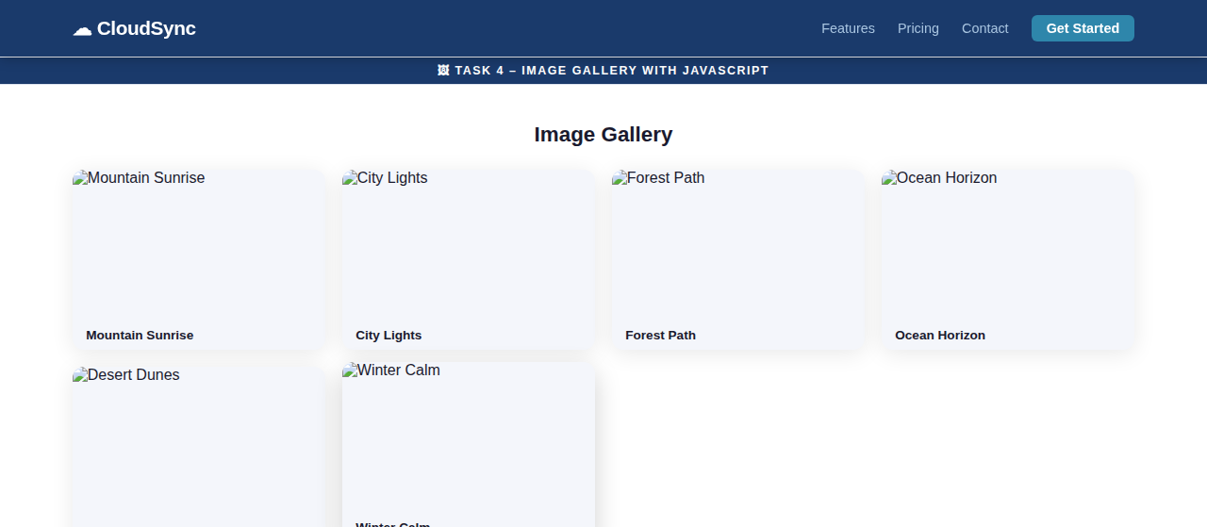
Figure 4.1 – Task 4 Output: Responsive image gallery grid
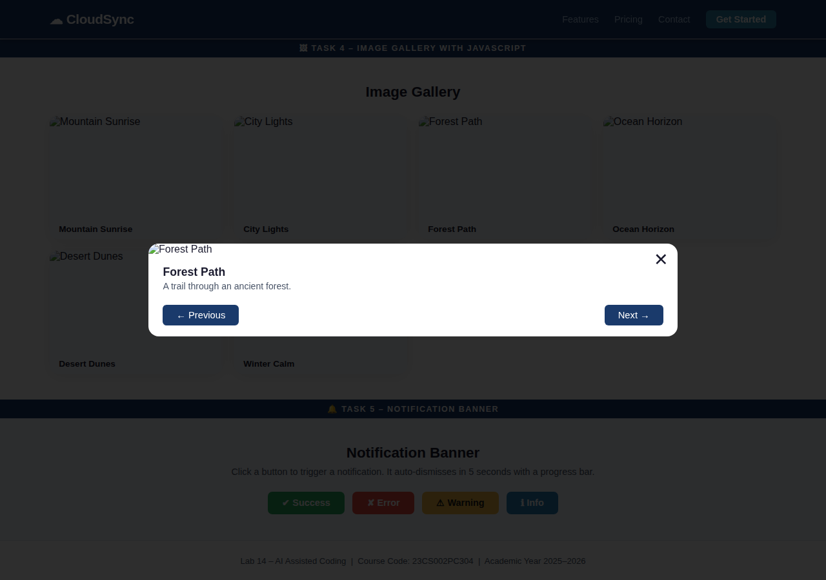
Figure 4.2 – Task 4 Output: Lightbox modal with navigation controls

Task 5: Notification Banner

5.1 Task Description
Display a notification banner at the top of the page. Use JavaScript to show and hide the banner. Style it with CSS. Use AI to ensure smooth transitions and clean UI behaviour.

5.2 AI Prompt Used
Prompt
"Create a notification/alert banner system for a webpage. The banner should appear at the top with a slide-down animation. Support four types: success (green), error (red), warning (amber), info (blue). Include a dismiss X button. Auto-dismiss after 5 seconds with a visible countdown progress bar. Queue multiple notifications without overlap. Use CSS transitions only (no external libraries). Make it fully accessible with ARIA live regions."

5.3 Code & Explanation
HTML – Banner Container
<!-- Banner container: fixed at top, managed by JavaScript -->
<div id="banner-stack" aria-live="polite" aria-atomic="true"></div>

<!-- Demo trigger buttons -->
<div class="demo-buttons">
<button onclick="notify('success', 'Changes saved successfully!')">Success</button>
<button onclick="notify('error', 'An error occurred. Please try again.')">Error</button>
<button onclick="notify('warning', 'Your session will expire in 5 minutes.')">Warning</button>
<button onclick="notify('info', 'New feature: Dark mode is now available.')">Info</button>
</div>
CSS – Banner Styles & Animations
#banner-stack {
position: fixed; top: 0; left: 50%;
transform: translateX(-50%);
width: min(560px, 95vw);
z-index: 9999;
display: flex; flex-direction: column; gap: 0.5rem;
padding-top: 0.75rem;
}

.banner {
display: flex; align-items: center; gap: 0.75rem;
padding: 0.85rem 1.1rem; border-radius: 10px;
box-shadow: 0 4px 18px rgba(0,0,0,0.15);
font-size: 0.95rem; font-weight: 500; color: #fff;
/* Start state: above viewport */
transform: translateY(-120%); opacity: 0;
transition: transform 0.35s cubic-bezier(0.34,1.56,0.64,1), opacity 0.35s;
overflow: hidden; position: relative;
}
.banner.show { transform: translateY(0); opacity: 1; }
.banner.hide { transform: translateY(-120%); opacity: 0; }

/* Type-specific backgrounds */
.banner.success { background: #27AE60; }
.banner.error { background: #E74C3C; }
.banner.warning { background: #F39C12; color: #1a1a1a; }
.banner.info { background: #2980B9; }

/* Countdown progress bar at banner bottom */
.banner-progress {
position: absolute; bottom: 0; left: 0;
height: 4px; background: rgba(255,255,255,0.45);
width: 100%;
transition: width linear;
}

/* Dismiss button */
.banner-close {
margin-left: auto; background: none; border: none;
color: inherit; font-size: 1.25rem; cursor: pointer;
line-height: 1; opacity: 0.8; transition: opacity 0.2s;
}
.banner-close:hover { opacity: 1; }
JavaScript – Notification System
const ICONS = { success: '&#10003;', error: '&#10007;', warning: '&#9888;', info: '&#8505;' };
const DURATION = 5000; // ms

function notify(type, message) {
const stack = document.getElementById('banner-stack');
const banner = document.createElement('div');
banner.className = `banner ${type}`;
banner.setAttribute('role', 'alert');

// Build inner HTML
banner.innerHTML = `
<span class="banner-icon">${ICONS[type]}</span>
<span class="banner-msg">${message}</span>
<button class="banner-close" aria-label="Dismiss">&times;</button>
<div class="banner-progress" id="prog-${Date.now()}"></div>
`;

stack.appendChild(banner);

// Trigger slide-in on next frame (allows CSS transition to run)
requestAnimationFrame(() => {
requestAnimationFrame(() => banner.classList.add('show'));
});

// Animate countdown bar
const bar = banner.querySelector('.banner-progress');
bar.style.transition = `width ${DURATION}ms linear`;
requestAnimationFrame(() => { bar.style.width = '0%'; });

// Auto-dismiss after DURATION
const timer = setTimeout(() => dismiss(banner), DURATION);

// Manual dismiss
banner.querySelector('.banner-close').addEventListener('click', () => {
clearTimeout(timer);
dismiss(banner);
});
}

function dismiss(banner) {
banner.classList.replace('show', 'hide');
// Remove from DOM after transition completes
banner.addEventListener('transitionend', () => banner.remove(), { once: true });
}

5.4 AI Assistance Notes
- AI identified the double requestAnimationFrame trick needed to trigger CSS transitions on dynamically created elements – a single rAF is not always sufficient because the browser may batch the style calculation.
- AI suggested the cubic-bezier(0.34,1.56,0.64,1) easing curve to give the banner a subtle spring/bounce effect on entry, making it feel more lively without using a JS animation library.
- AI recommended stacking multiple banners vertically in a flex column container rather than replacing them, so rapid notifications don't clobber each other.
- AI advised using the { once: true } option on the transitionend listener so the handler removes itself automatically after firing, preventing memory leaks.
- AI confirmed that aria-live='polite' on the container makes screen readers announce new banners without interrupting ongoing speech.

5.5 Expected Output
Clicking any demo button causes a coloured notification banner to slide down from the top of the viewport with a spring animation. A white progress bar at the bottom of each banner shrinks to zero over 5 seconds, then the banner slides back up and is removed. Clicking the X button dismisses it immediately. Multiple banners stack vertically and each auto-dismiss independently.
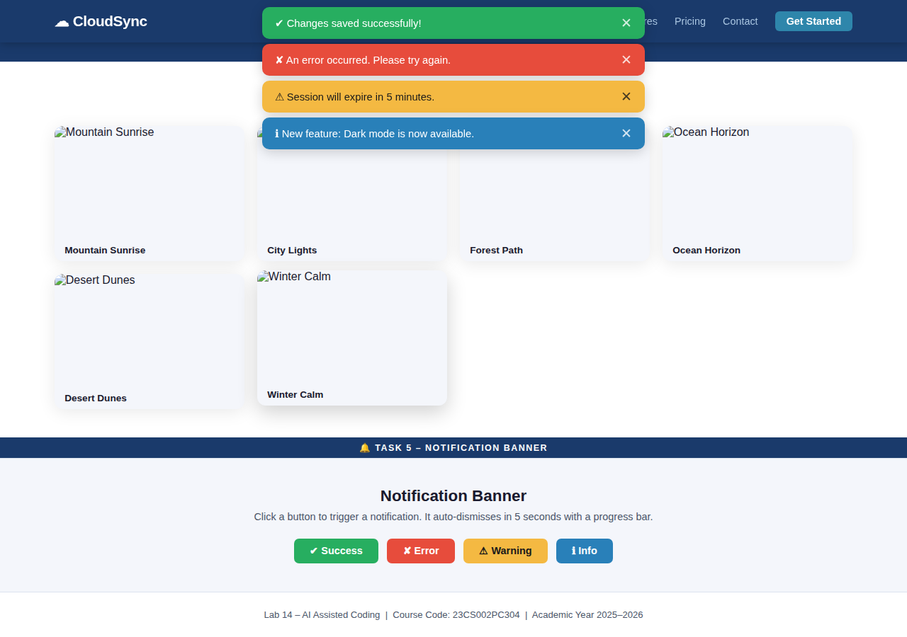
Figure 5.1 – Task 5 Output: All four notification banner types displayed simultaneously

Lab Summary & Learning Outcomes

Tasks Completed
# | Task | Technologies Used | Key Concept
1 | Landing Page Design | HTML5, CSS Flexbox/Grid, Google Fonts | Responsive layout
2 | Theme Toggle Feature | CSS Variables, JavaScript, localStorage | Accessibility & persistence
3 | User Feedback Form | HTML Forms, JS Validation, CSS Transitions | Client-side validation
4 | Image Gallery | JavaScript DOM, CSS Grid, Lightbox Modal | Dynamic rendering
5 | Notification Banner | JavaScript, CSS Transitions, ARIA | Animation & UX patterns

Key AI-Assisted Design Principles Applied
- Responsiveness: CSS Grid auto-fill/minmax and clamp() for fluid layouts that adapt without brittle breakpoints.
- Accessibility: ARIA roles, aria-live regions, colour-contrast validation, and keyboard navigation throughout all tasks.
- Performance: lazy image loading, requestAnimationFrame for DOM transitions, and localStorage for persisting user preferences.
- Progressive Enhancement: all tasks function as HTML-only fallbacks; JavaScript enhances rather than replaces basic functionality.
- Clean Architecture: CSS custom properties for theming, data arrays for gallery content, and modular JavaScript functions improve maintainability.

End of Lab 14 Report

